# Target Metrics

Overall - Accuracy: 0.8300, Precision: 0.8617, Recall: 0.8300, F1: 0.8338

Class-specific metrics:

Carbon neutral(ity) - Precision: 0.7407, Recall: 0.8000, F1: 0.7692

Emissions reduction target - Precision: 1.0000, Recall: 0.7600, F1: 0.8636

Net zero - Precision: 0.7059, Recall: 0.9600, F1: 0.8136

No target - Precision: 1.0000, Recall: 0.8000, F1: 0.8889

# Year Metrics

Overall - Accuracy: 0.8300, Precision: 0.8300, Recall: 0.8300, F1: 0.8271

Class-specific metrics:

2020 - Precision: 0.0000, Recall: 0.0000, F1: 0.0000

2022 - Precision: 0.0000, Recall: 0.0000, F1: 0.0000

2025 - Precision: 0.6000, Recall: 0.6000, F1: 0.6000

2030 - Precision: 0.8077, Recall: 0.8400, F1: 0.8235

2031-32 - Precision: 0.0000, Recall: 0.0000, F1: 0.0000

2032 - Precision: 0.0000, Recall: 0.0000, F1: 0.0000

2035 - Precision: 0.8333, Recall: 1.0000, F1: 0.9091

2040 - Precision: 0.7500, Recall: 0.9000, F1: 0.8182

2050 - Precision: 0.8571, Recall: 0.8889, F1: 0.8727

No target - Precision: 1.0000, Recall: 0.8400, F1: 0.9130

# Other Metrics

Quote Accuracy: 0.9500

Overall Accuracy: 0.7600

Valid XML Percentage: 1.0000

# Confusion Matrices

Target Confusion Matrix:

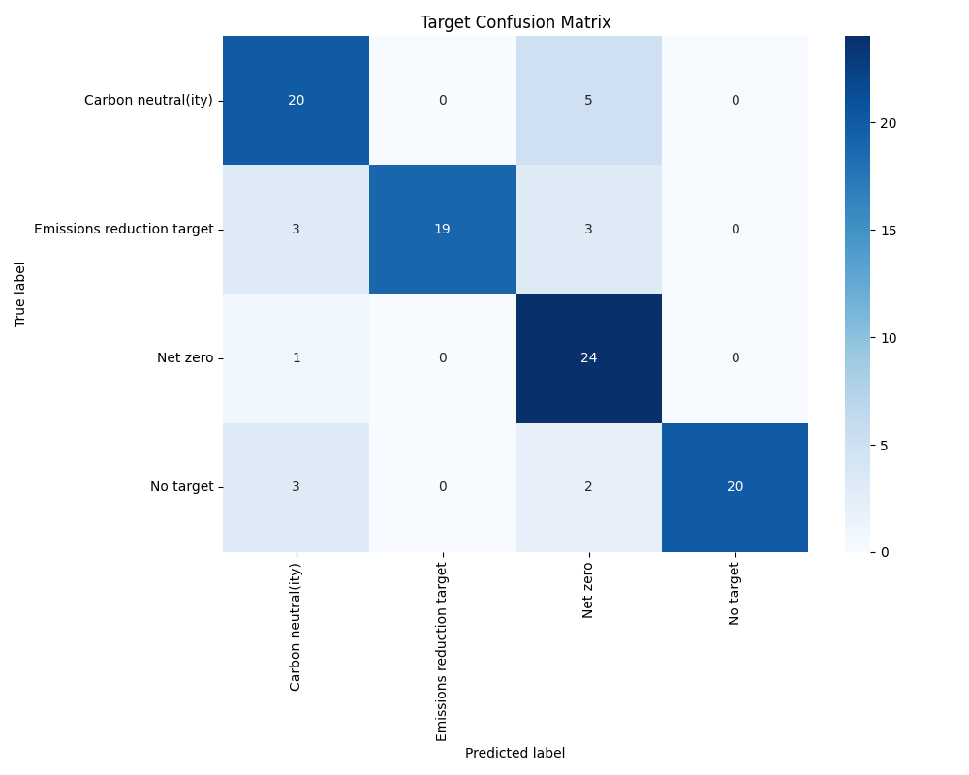

Year Confusion Matrix:

